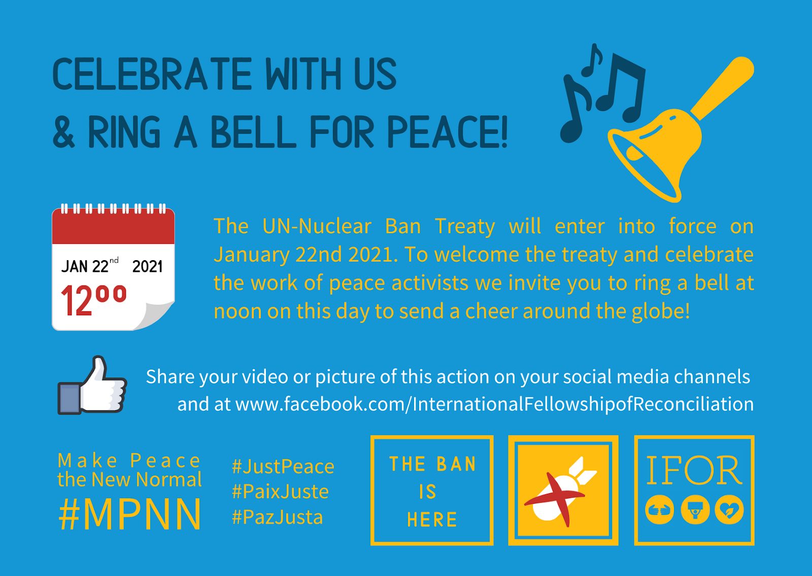

Noon (your local time) on January 22nd 2021 is the moment we’re asking you to celebrate the Treaty and make noise for peace. We’d like you to find a bell and ring it!

Whether it’s your Tibetan Tingsha Cymbals, arranging for a local cathedral or church bell, or simply standing on your doorstep banging saucepan with a spoon -- this is a moment to celebrate a monumental occasion.

To successfully do this, all you need to do is find a bell, ring it, and send either a photo or video to our social media channel (https://www.facebook.com/InternationalFellowshipofReconciliation/) or email to office@ifor.org. This simple action, possible regardless of the Covid status of your country, is one that everyone can do. It helps remind us that it’s millions of people around the world like you, who made the treaty possible.

If you are part of a local peace or religious group, then invite them to get involved as well. Share the bells at noon and encourage them to take part. If you are allowed to gather, then get a group together and ring. If you are not, get key people to record their ringing and share that at noon.

-download the graphic here-
https://static1.squarespace.com/static/54c00acde4b022a64cd0266b/t/6002e1f4a7e7ba5564a6befc/1610801653365/Ring+the+bell+Graphic+1.png

